

**LOVELY**

**PROFESSIONAL**

**UNIVERSITY**



**Submitted to: Submitted By:**

**Dr. Mohammad Faiz Aman Kumar (Cse 326 ) Yash Siwach**

**Aman Redhu**

**HTML PROJECT**

* **We may sell property from**

**this site.**

* **We buy property from this**

**Site.**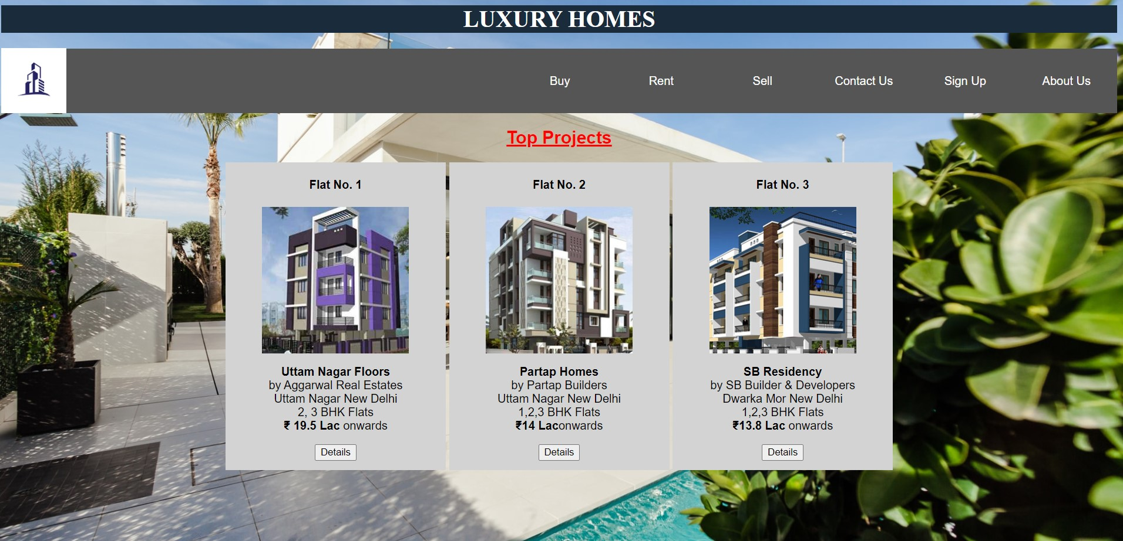

**Project Work**

* **Aman Kumar :- Progress Report.**
* **Aman Redhu :- Project file.**
* **Yash Siwach :- Web. Coding/Project File.**

**Thank you**